NEXTAG COMPANY

CALVIN KEILN - LEATHER CK LOGO ZIP-AROUND CONTINENTAL WALLET

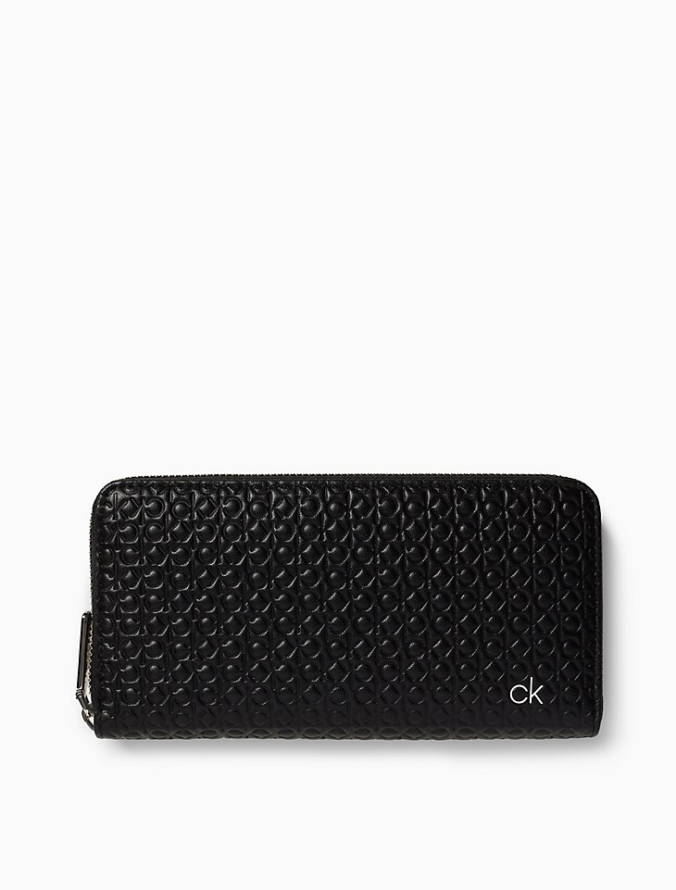

##### **Detail**

Designed with an allover ck logo, this sleek wallet is made with glossy leather, a zip-around closure, an interior zip divider pocket and multiple bill and card slots.

• leather ck logo zip-around continental wallet

• allover ck logo design

• zip around closure

• interior zip divider pocket

• 2 large bill slots

• 12 card slots

• 7.5" wide x 3.9" tall x 0.8" deep

Style #: 37105129   
Universal Style #: K60K605129

##### **CARE & COMPOSITION**

• Leather

• Imported